Harvest Festival 2020

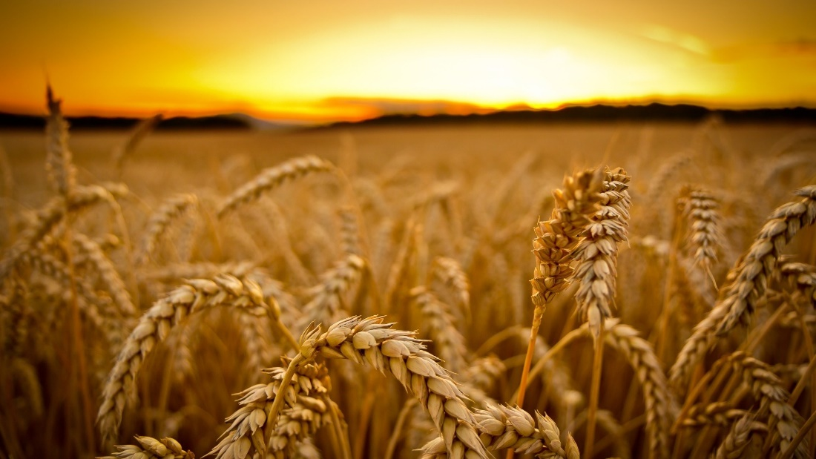

Welcome and Opening Prayer we sit

God you are at the centre of creation. Hear our prayer of thankfulness for the gift of land, the natural order, and the environment, and particularly, for the richness and diversity of the countryside of Cornwall. You give us a responsibility to work with you in maintaining this richness and diversity. Hear our prayer to encourage us all to play our part in preserving and sustaining it.

You bring us into partnership to work within creation and, through the efforts of the farmer and grower, bring forth fruitfulness and food from the land. Hear our prayer for the agricultural community in Cornwall, bearing the strain of the uncertainties of the weather, providing us with food for our well being, and enhancing the beauty of the countryside.

You call people to live and work in community with others, reflecting the kingdom. Hear our prayer for villages and rural towns across Cornwall; teach us how to build caring and supportive communities

so that we help and support one another and make us grateful for the joy of companionship. These prayers and thanksgivings we offer in the name of Jesus your Son. Amen.

A prayer for Harvest 2020
Loving God, we give thanks for those who produce our food: for farmers and fishermen, factory and shop workers. We pray for those for whom this has been a difficult year: farmers who have battled the weather to grow food, delivery drivers and shop workers who kept working despite the pandemic. Help us to value and support each other. In Jesus’ name. Amen.
Those with a mask can hum to this harvest hymn. If there are 6 folk who would like to make a socially distanced choir we can arrange this.
We stand
Come ye thankful people come,
raise the song of harvest home.
All is safely gathered in,
‘ere the winter storms begin;
God, our maker doth provide,
all our wants to be supplied;
Come to God’s own temple come,
raise the song of harvest home.

Then, thou Church triumphant come,
raise the song of harvest home
All be safely gathered in,
free from sorrow, free from sin
There forever purified in God’s garner to abide:
Come ten thousand angels, come,
raise the glorious harvest home!

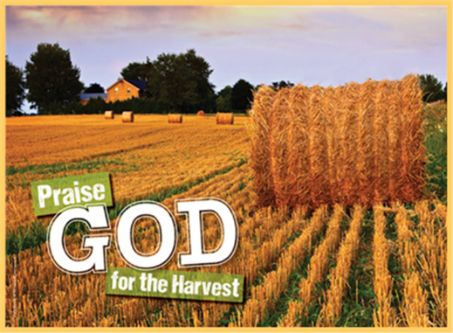
Creator God, the whole earth proclaims your glory. Field and forest, farm and garden all sing your praise! As we gaze at the world around us, we see your handiwork; your fingerprint is everywhere. This is your world; help us to enjoy it gently. In Jesus’ name. Amen

Confession we sit or kneel
God has blessed us. But still God’s children go hungry.
Lord have mercy Lord have mercy

God has blessed us. But still the poor cry out for justice.
Christ have mercy Christ have mercy

God has blessed us. But still we see inequality
and oppression in the earth.
Lord have mercy Lord have mercy
May God show us his mercy, restore us in his likeness and give us generous hearts and lives. Amen.

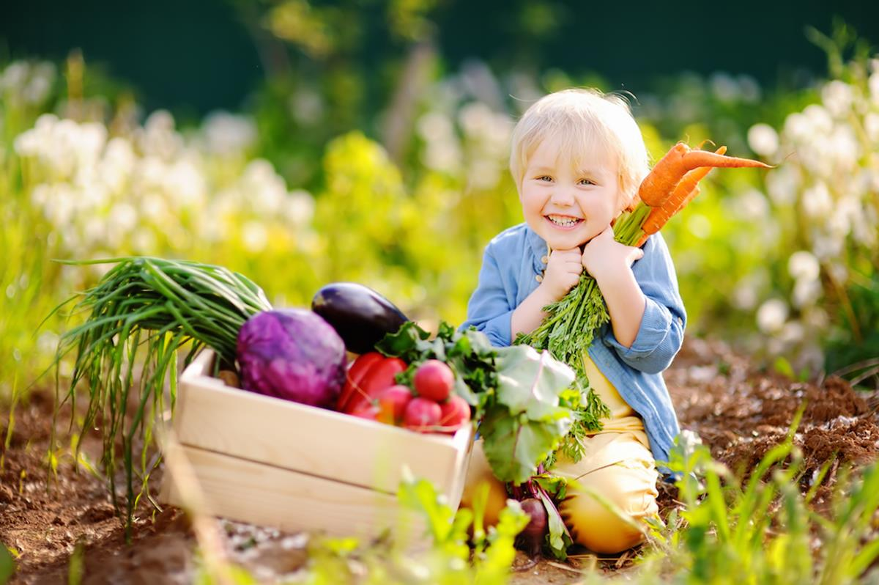
We stand
Land’s End people and churches - bless the Lord. All you deaneries, parishes and farms, coast paths and seashore, meadows and trees – bless the Lord. Praise and extol him for ever and ever.

All you big things – bless the Lord. Cathedral and farms, seas and rivers bless the Lord. Praise and extol him for ever and ever.

All you tiny things – bless the Lord. Goldfinch and harvest mouse, Pollen dust, grains of corn, Linseed, grass seed, wheat ears, barley awn, dragonfly and lady birds – bless the Lord. Praise and extol him for ever and ever.

All you sharp things – bless the Lord. Hayfork tines and rose thorns, Ploughshare, teasels, sword sharp stubble, Disc harrows, flails and barbed wire - bless the Lord. Praise and extol him for ever and ever.

All you soft things – bless the Lord. Fleeces, hay bales, silage bags, thistledown, November fog and summer rain - bless the Lord. Praise and extol him for ever and ever.
All you sweet things – bless the Lord. Blackberries and field bean flowers, Honey, vining peas and plums, Sugar beet and molasses -bless the Lord. Praise and extol him for ever and ever.

All you bitter things- bless the Lord. Crab apples and sloes, Home brewed beer and A sharp northerly wind – bless the Lord. Praise and extol him for ever and ever.

All you swift things – bless the Lord. Wild rabbit and weasel, Red deer, Red Arrows, Air ambulance, sparrow hawk and hares, -bless the Lord. Praise and extol him for ever and ever.

All you slow things – bless the Lord. A winter thaw, a garden snail, , Jersey, Guernsey and Friesian cattle - bless the Lord. Praise and extol him for ever and ever.

All you loud things – bless the Lord. Tractors and trailers, Combine drum, balers, A pheasant’s alarm, barking foxes and Chain saw engines – bless the Lord. Praise and extol him for ever and ever.

All you quiet things –bless the Lord A swooping barn owl and a stalking cat, Sticklebacks, minnows, Drifting cloud, freshly harvested fields, And full stores of grain- bless the Lord. Praise and extol him for ever and ever.

‘Now all you creatures that never talk’ – still bless the Lord. Praise and extol him for ever and ever.

Collect
Creator God, You made the goodness of the land, the riches of the sea and the rhythm of the seasons; as we thank you for the harvest
may we cherish and respect this planet and its peoples, through Jesus Christ our Lord. Amen

Reading from Deuteronomy 26: 1-11 we sit
This is the word of the Lord
Thanks be to God.

Reflection

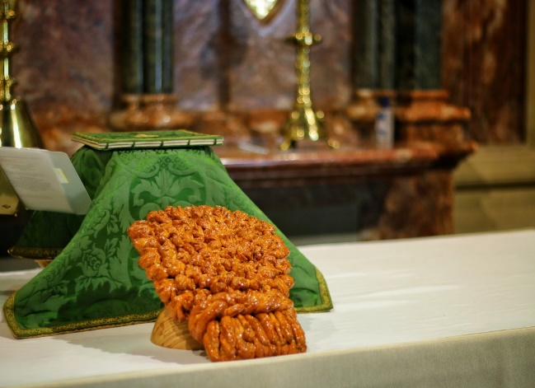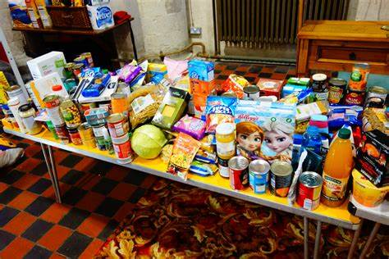

The Offering of Soil
We bring topsoil, symbol of that which you have created and sun and rain have nurtured. You have laid the foundations of earth: and the heavens are the work of your fingers.
The earth is the Lord's and all that is in it:
The compass of the world and those that dwell therein.

The Offering of Seed
We bring the harvest of seeds for next year's crops.
You bring forth grass for the cattle and all things green for us to use.
That they may sow their land to yield them fruits of increase:
He blesses them so that they multiply greatly.

The Offering of Grain
We bring the harvest of our cornfields.
You prepare the corn, for so you provide the earth.
We cannot live by bread alone:
But by every word that proceeds from the mouth of God.

The Offering of Fruit and Vegetables
We bring the harvest of fruit and vegetables,
The tree bears her fruit, the earth has yielded its increase.
He gives food to all flesh: For his mercy endures for ever.

The Offering of Animal Produce
We bring the produce of our dairies, together with wool and leather. You cause the grass to grow for the cattle.
You open wide your hand: And fill all things with your bounteous gift.

The Offering of Flowers and Vineyards
We bring the harvest of flowers and of vineyards. The gardens and meadows bloom, the fig tree and vine yield their fruit.
You bring beauty out of the earth: And wine that makes glad the human heart.

The Offering of Food
In this loaf of bread we bring the harvest of our lands. For bread is the source of human strength and the fruit of human hands.

Brothers and sisters, do not forget that God calls us to be good stewards of our land and our heritage. As we give thanks we commit ourselves to be good stewards of the earth and of our lives. We commit ourselves to share with our neighbours not only the food we produce and the land we tend but also the joy of knowing that all good things come from you, the Creator, Redeemer, and Sustainer.

O God our Father, we thank you that once again you have fulfilled your gracious promise that, while earth remains, seedtime and harvest shall not fail. We bless you for the kindly fruits of the earth which you have given to our use. Teach us, when we pray, that it is not by bread alone that we live; and grant us evermore to feed on Him who is the true bread from heaven, even Jesus Christ our Lord; to whom with you and the Holy Spirit, be all honour and glory, world without end. Amen

Prayers of Intercession Concluding with The Lord’s Prayer
Our Father, who art in heaven, hallowed be thy name; thy kingdom come; thy will be done; on earth as it is in heaven. Give us this day our daily bread. And forgive us our trespasses, as we forgive those who trespass against us. And lead us not into temptation; but deliver us from evil. For thine is the kingdom, the power and the glory, for ever and ever. Amen.
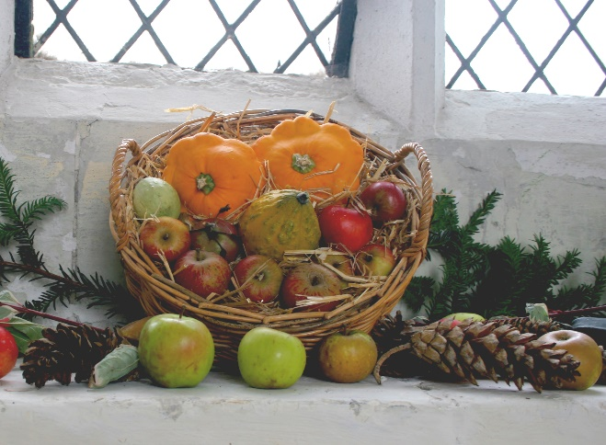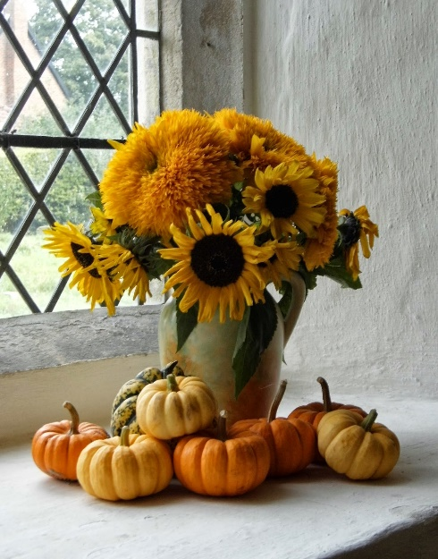

Prayers of Thanksgiving we stand
For fields that are harvested, and grain stores that are full.
For crops that that have achieved their potential
and for those that are still to deliver their yield.
For the assurance of ample provision with enough to spare,
and for the knowledge that we will know neither the fear nor the threat of hunger. Father, for all the good things of this life we give you thanks and praise.

For the opportunity to share our plenty with those who have little.
For the individuals and charities who exercise such care on our behalf. For compassion expressed and help that is given. Father, for all the good things of this life we give you thanks and praise.

For the skill and experience of those who till the land and care for the stock. For the proud tradition of agricultural and horticultural expertise, that characterises the life of this County. For the proficiency of its engineers and scientists, whose knowledge has brought increased efficiency and better yields. Father, for all the good things of this life we give you thanks and praise.

For the sharing of knowledge between one generation and another.
For those who have extended our horizons with their enthusiasm and commitment to learning. Father, for all the good things of this life we give you thanks and praise.
Those with a mask can hum to this harvest hymn. If there are 6 folk who would like to make a socially distanced choir we can arrange this.

We plough the fields and scatter
the good seed on the land
But it is fed and watered by God’s almighty hand;
He sends the snow in winter,
the warmth to swell the grain
The breezes and the sunshine, and soft refreshing rain.
All good gifts around us are sent from heav’n above
Then thank the Lord, O thank the Lord for all his love.

We thank thee then O Father
for all things bright and good
The seedtime and the harvest,
our life, our health, our food.
Accept the gifts we offer
for all thy love imparts,
And what thou most desirest,
our humble grateful hearts.
All good gifts around us are sent from heav’n above
Then thank the Lord, O thank the Lord for all his love.

Blessing
Bless to us, O God the sun that shines above us
The rain that falls upon us the earth that sustains us
The air that surrounds us the love that binds us. Amen

May God who has made us, who loves us and who gives us life
bless and keep us, now and always. Amen.

Acknowledgements: Liturgy from the Arthur Rank Centre (arthurrankcentre.org.uk)

Please give generously to the collection for the Food Bank in Penzance, they are struggling to cope with the increasing demands during this phase of the Pandemic.

